**VISVESVARAYA TECHNOLOGICAL UNIVERSITY**,

**BELAGAVI – 5900 18**

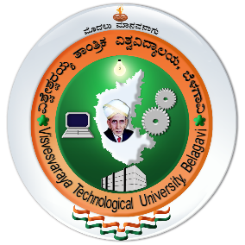

**STUDENT HANDBOOK FOR EARNING ACTIVITY POINTS**

**Submitted in partial fulfillment of the requirements of the award of degree**

**of**

**BACHELOR OF ENGINEERING**

**IN**

**INFORMATION SCIENCE & ENGINEERING**

**Submitted By:**

**Cauvery K P [4VV19IS015]**

**UNDER THE GUIDANCE OF**

**Prof. CHAYASHREE G**

**Assistant Professor**

**Dept of IS&E**

**VVCE, Mysuru**

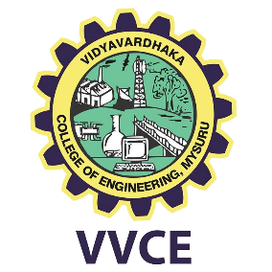

**2022 -2023**

**DEPARTMENT OF INFORMATION SCIENCE AND ENGINEERING VIDYAVARDHAKA COLLEGE OF ENGINEERING**

**MYSURU-570002**

**EVENT REPORT**

1. Activity Name: ENERGY LITERACY TRAINING

|  |  |  |
| --- | --- | --- |
| **SL NO.** | **PARTICULARS** | **DESCRIPTION** |
| 1 | Event Number | **01** |
| 2 | Date | **23/03/2023** |
| 3 | Duration | **3 DAYS** |
| 4 | Place | **MYSORE** |
| 5 | Activity Points Earned | **15** |
| 6 | Semester | **VIII** |
| 7 | Academic Year | **2022-23** |

**Brief Report on the Activity:**

This is a training program of 12 modules which is part of the “Energy Literacy Training” of the Energy Swaraj Foundation. The training helps people in understanding energy, its generation, consumption, wastage, carbon footprint, impact on the environment and solution methods.

**Energy Swaraj Foundation (ESF)**, is a not-for-profit organization, working to establish Energy Swaraj - Energy by locals for locals. Based on the Gandhian Principle of Gram Swaraj - Energy Swaraj makes local communities self-sufficient in Energy by enabling localized production and consumption. The Energy Swaraj Foundation believes for corrective climate action a major transformation in energy generation and consumption towards renewable energy can be achieved not by the governments around the world or their policies, but through the involvement of the public.

# Certificate of the Activity:

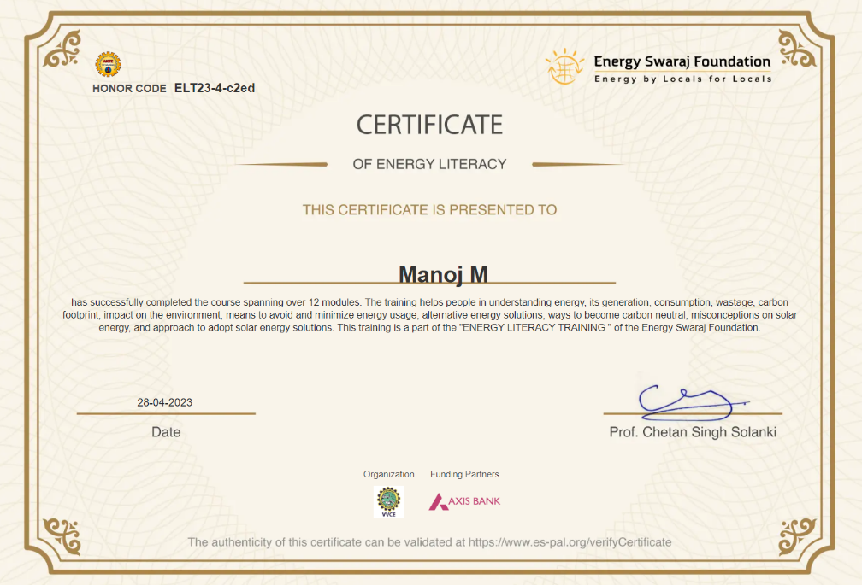

# Signature of the Student Signature of the Coordinators

**EVENT REPORT**

2. Activity Name: NASHE MUKTHA BHARATHA

|  |  |  |
| --- | --- | --- |
| **SL NO.** | **PARTICULARS** | **DESCRIPTION** |
| 1 | Event Number | **02** |
| 2 | Date | **14/11/2022** |
| 3 | Duration | **3 HOURS** |
| 4 | Place | **MYSORE** |
| 5 | Activity Points Earned | **5** |
| 6 | Semester | **VII** |
| 7 | Academic Year | **2022-23** |

**Brief Report on the Activity:**

Nasha Mukt Bharat Abhiyaan intends to reach out to the masses and spread awareness about substance abuse through various activities like:

* Awareness generation programs
* Focus on higher educational Institutions, university campuses and schools
* Reaching out to the Community and identifying dependent population
* Focus on counselling and treatment facilities in hospitals and rehabilitation centres that have been geo-tagged
* Capacity building programs for service providers.

# Certificate of the Activity:

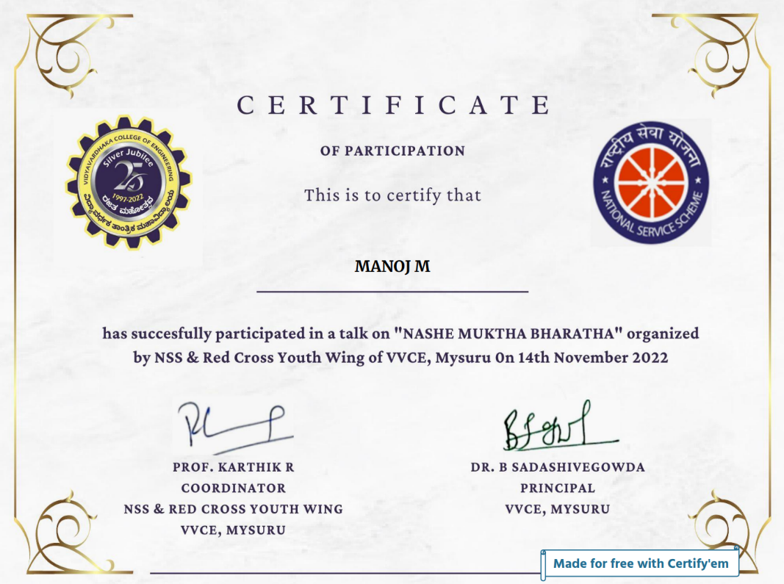

# Signature of the Student Signature of the Coordinators

**EVENT REPORT**

3. Activity Name: SURVEY CAMP

|  |  |  |
| --- | --- | --- |
| **SL NO.** | **PARTICULARS** | **DESCRIPTION** |
| 1 | Event Number | **03** |
| 2 | Date | **16/11/2022** |
| 3 | Duration | **1 DAY** |
| 4 | Place | **JABAGERE** |
| 5 | Activity Points Earned | **20** |
| 6 | Semester | **VII** |
| 7 | Academic Year | **2022-23** |

**Brief Report on the Activity:**

The NSS and Red Cross Youth Wing of Vidyavardhaka College of Engineering in Mysore, Karnataka arranged a survey camp on 16th November in Jabagere with the aim of collecting information about the possession of government documents among the local population. The volunteers visited each household and conducted the survey, successfully covering all of them. The data gathered during the survey will be utilized to plan and execute government schemes and initiatives.

The camp not only helped to collect important data for the government but also fostered a sense of social responsibility and community engagement among the volunteers.

# Certificate of the Activity:

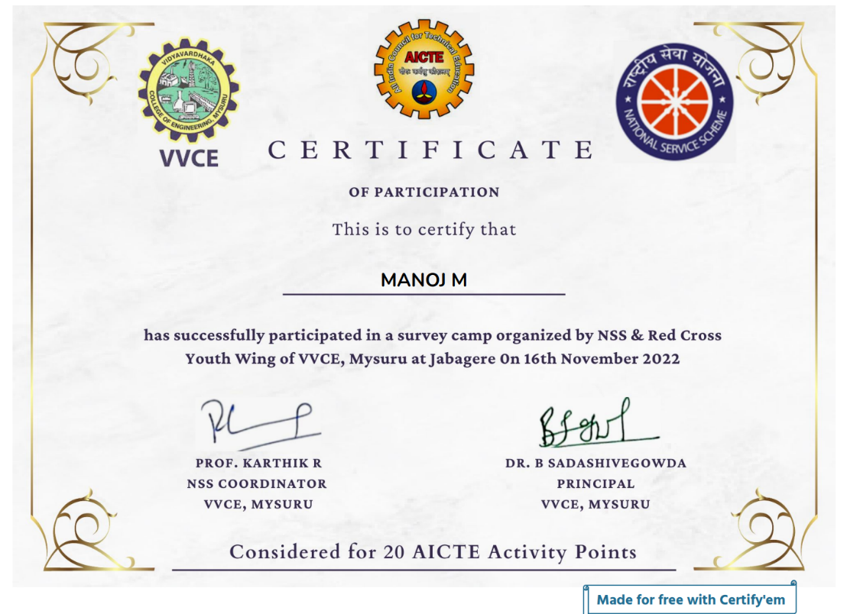

# Signature of the Student Signature of the Coordinators

**EVENT REPORT**

4. Activity Name: MARATHON

|  |  |  |
| --- | --- | --- |
| **SL NO.** | **PARTICULARS** | **DESCRIPTION** |
| 1 | Event Number | **04** |
| 2 | Date | **11/12/2022** |
| 3 | Duration | **1 DAY** |
| 4 | Place | **MYSURU** |
| 5 | Activity Points Earned | **10** |
| 6 | Semester | **VII** |
| 7 | Academic Year | **2022-23** |

**Brief Report on the Activity:**

The Silver Jubilee Run was organized by NSS & Red cross youth wing of Vidyavardhaka College of Engineering on 11th December, 2022. This marathon was conducted on the theme of “Wild Life Conservation”. It was aimed to spread awareness about protection of forest and wildlife. The run started at 7 in the morning and was 5Km long run. Students and professors ran together for this cause.

Overall, the run served as a powerful reminder of the urgent need to protect our planet's biodiversity and inspired many to take action in their own communities.

# Certificate of the Activity:

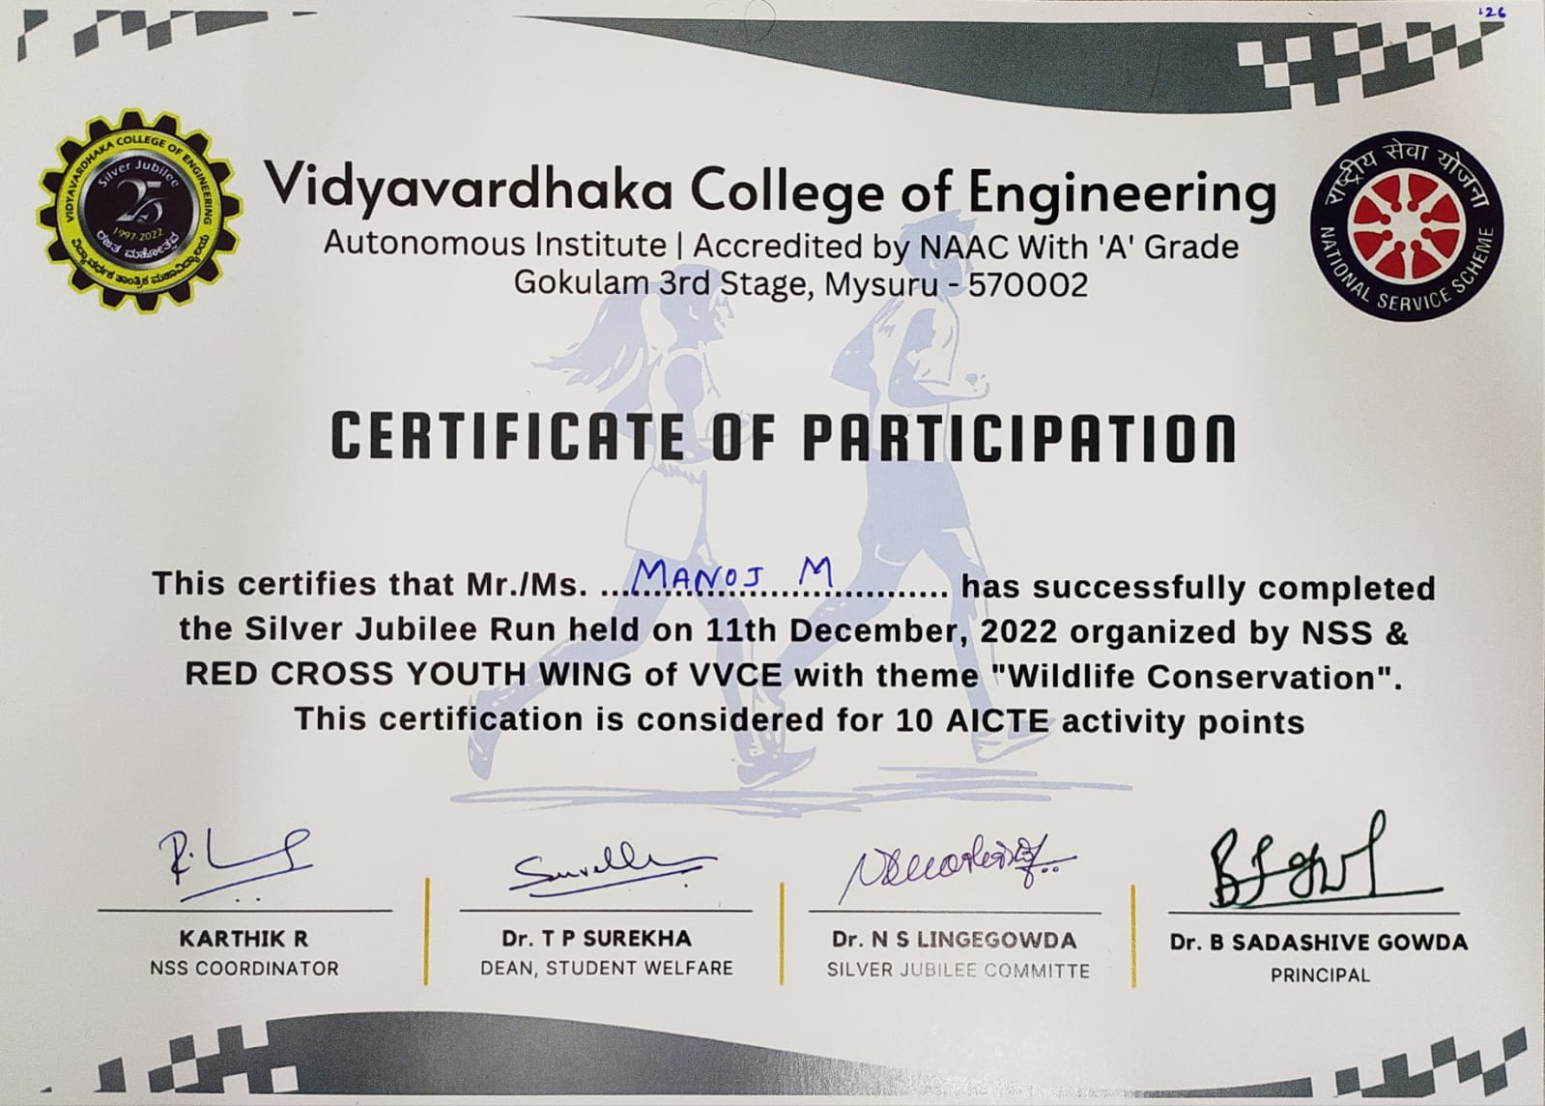

# Signature of the Student Signature of the Coordinators